AXN/RXN W.S.
In the example below, the action-reaction pair is shown by the arrows (vectors), and the action-reaction described in words.
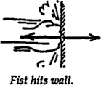

- For the remaining situations, discuss with your neighbor the direction of the "action" vectors.

- In the first form provided, verbally state the "reaction" to the given "action".
- In the second form provided, state the direction of the "reaction" vector.

  - Statement:

Direction:
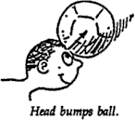

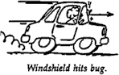
  - Statement: Direction:
Situation a
Situation b
Situation c

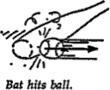
  - Statement: Direction:

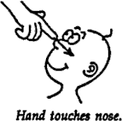

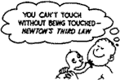

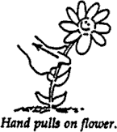
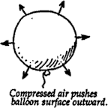
    - Statement: Direction:
Situation d
Situation e

Situation f
Situation g

    - Statement: Direction:
      - tatement: Direction:

      - Statement: Direction:

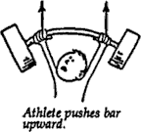

Refer to the following information for the next six questions.

2. Discuss with your partner and then list the chain of at least six pairs of action-reaction forces shown in the diagram given below.
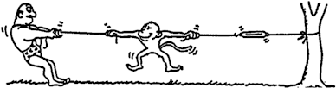

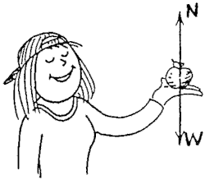
Refer to the following information for the next thirteen questions.

3. Nellie Newton holds an apple weighing one newton at rest on the palm of her hand. The force vectors shown are the forces that act on the apple.

- To say the weight of the apple is 1 N is to say that a downward gravitational force of 1 N is exerted on the apple by .

the earth | her hand

- Nellie's hand supports the apple with normal force N, which acts in a direction opposite to W. We can say N .

equals W | has the same magnitude as W

- Since the apple is at rest, the net force on the apple is .

zero | nonzero

- N is equal and opposite to W. We say that N and W comprise an action-reaction pair.

can | cannot

- The reason is because action and reaction always ,

act on the same object | act on different objects

and here we see N and W .

both acting on the apple | acting on different objects

- In accord with the rule, "If ACTION is A acting on B, then REACTION is B acting on A," if we say action is the earth pulling down on the apple, reaction is .

the apple pulling upon the earth
Nellie's hand pushing up on the apple

- To repeat for emphasis, we see that N and W are equal and opposite to each other
.

and comprise an action-reaction pair
but do not comprise an action-reaction pair

- Another pair of forces is N [shown] and the downward force of the apple against Nellie's hand [not shown]. This force pair an action-reaction pair.

is | is not

- Suppose Nellie now pushes upward on the apple with a force of 2 N. The apple .

is still in equilibrium | accelerates upward

and compared to W, the magnitude of N is .

the same
twice
not the same, and not twice

- Once the apple leaves Nellie's hand, N is .

zero | still twice the magnitude of W

and the net force on the apple is .

zero | only W | still W - N, a negative force

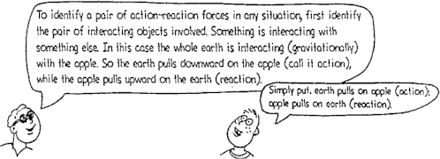
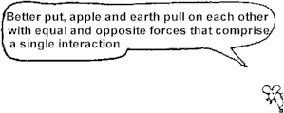

Refer to the following information for the next two questions.

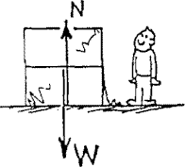
- A crate filled with delicious junk food rests on a horizontal floor. Only gravity and the support force of the floor act on it, as shown by the vectors for weight W and normal force N.
- The net force on the crate is .

zero | greater than zero

- Evidence for this is .

Refer to the following information for the next three questions.

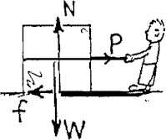
- A slight pull P is exerted on the crate, not enough to move it.
  - A force of friction f now acts, which is P.

less than | equal to | greater than

  - This type of friction is called friction.

static | sliding or kinetic | rolling

  - The net force on the crate is .

zero | greater than zero
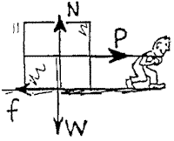
Refer to the following information for the next four questions.

6. The pull on the crate is increased until the crate begins to move. It is pulled with pull P so that it moves with constant velocity across the floor.
- Friction f is P.

less than | equal to | greater than

- This type of friction is called friction.

static | sliding or kinetic | rolling

- Constant velocitv means acceleration is .

zero | greater than zero

- The net force on the crate is zero.

less than | equal to | greater than

Refer to the following information for the next two questions.

- Pull P is further increased and is now greater than friction f.
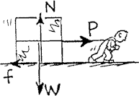
  - The net force on the crate is zero.

less than | equal to | greater than

  - The net force acts toward the right, so acceleration acts toward the

left | right

- Summary Questions

  - If the pulling force P is 150 N and the crate doesn't move, what is the magnitude of the static friction, f?

  - If the pulling force P is 200 N and the crate doesn't move, what is the magnitude of the static friction, f?

  - If the force of sliding friction is 250 N, what force is necessary to keep the crate sliding at constant velocity?

  - If the mass of the crate is 50 kg and sliding friction is 250 N, what is the acceleration of the crate when the pulling force is 250 N?

  - If the mass of the crate is 50 kg and sliding friction is 250 N, what is the acceleration of the crate when the pulling force is 300 N?

  - If the mass of the crate is 50 kg and sliding friction is 250 N, what is the acceleration of the crate when the pulling force is 500 N?

On a previous worksheet we considered only the weight vector W for a block on a friction-free incline. Here we also consider the normal force N.

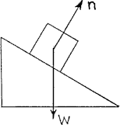
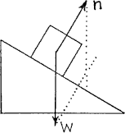
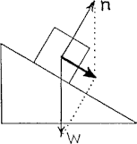

With no friction, Only two forces act: W and N. We put the tail of N at the block's center to coincide with the tail of W - so we can better find the resultant  via the parallelogram rule. | We construct a parallelogram [dotted lines] whose sides are W and N to find the resultant W + N. | The resultant is the diagonal as shown [bold vector]. This is the net force on the block.

- Note the net forces [bold vectors] for the blocks below.
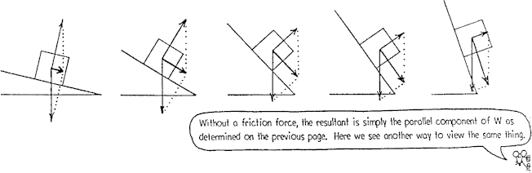
  - For a steeper incline, N .

increases | stays the same | decreases

  - For a steeper incline, the net force .

increases | stays the same | decreases

  - How does the net force compare to the parallel component of W as determined on the previous worksheet?

Refer to the following information for the next five questions.

- The block slide down a curved ramp. In each location, the net force resultant of W and N are parallel to the ramp surface. Draw N for location A, B, and C, and construct parallelograms and the net forces.

  - At which location is the net force greatest?

A | B | C

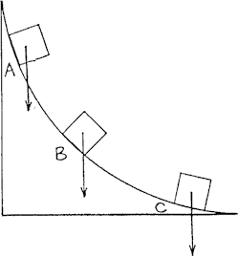
  - At which location is the acceleration greatest?

A | B | C

  - As the speed of the block increases, acceleration .

increases | remains constant | decreases

  - On inclined flat planes, acceleration down the incline .

remains constant | varies

  - On curved inclines, acceleration .

remains constant | varies
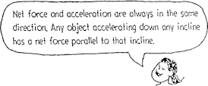
Refer to the following information for the next question.

11. The block is at rest on a horizontal surface. The normal support force n is equal and opposite to weight W.

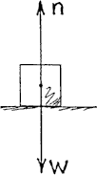
a. There is because the block has no tendency to slide.

friction | no friction

Refer to the following information for the next four questions.

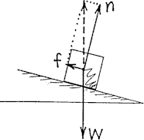
- At rest on the incline, friction acts. Note in the diagram below and to the right that the resultant f + n, shown by the dashed vector, is equal and opposite to W.
- Here we see that the size of n is the size of W.

less than | equal to | greater than

- You draw the resultant f + n for the block at rest on the steeper incline.
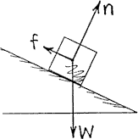

- The resultant magnitude of f + n is the magnitude of W.

less than | equal to | greater than

- As the angle of the incline increases, the magnitude of vector n .

decreases | stays the same | increases

- The block remains at rest on the still steeper incline. You draw in the vectors for equilibrium.

- How does the resultant f + n compare to W?

Refer to the following information for the next four questions.

- Suppose the angle is increased and the block slides down the incline at constant velocity.
  - Then the net force on the block is .

zero. | greater than zero.

  - If the angle is increased even further, then acceleration .

occurs | doesn't occur

  - Further steepness of the incline means acceleration down the plane.

less | more

  - When the incline is vertical, acceleration is .

less than g | g | more than g

FBD Worksheet
In each case, a rock is acted on by one or more forces. On a sheet of paper, draw an accurate vector diagram showing all forces acting on the rock, and no other forces. Use a ruler, and do it in pencil so you can correct mistakes.
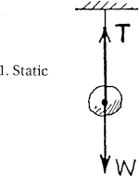
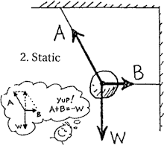
Refer to the following information for the next two questions.

The first two diagrams are done as examples.

In the second diagram notice that the parallelogram rule shows the vector sum of A + B is equal and opposite to W (that is, A + B = -W). Also note that the vector along string A is longer than the vector along string B. This signifies that the tension in string A is greater than the tension in string B.

Using a common length for each weight vector complete a parallelogram for diagrams 3 and 4. Then state which tension vector (in the left string or in the right string) is stronger; or if they are equal.
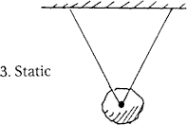

left string | right string | equal tensions

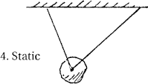

left string | right string | equal tensions

Refer to the following information for the next eight questions.

In each situation, draw and label vectors for the appropriate forces. Then select which forces were present in each diagram:
N for normal force
f for frictional force
W for gravitational force or weight
AR for air resistance
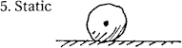

W | N | f

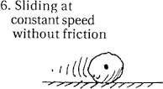
W | N | f

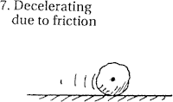
W | N | f

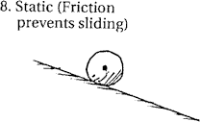
W | N | f

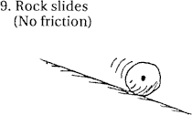
W | N | f

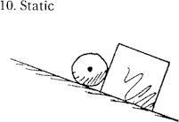
W | N | f

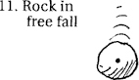
W | N | f | AR

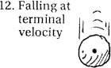
W | N | f | AR

- Consider the apple at rest on the table. If we call the gravitational force exerted on the apple action, what is the reaction force according to Newton's 3rd law?

- If a Mack truck and a Volkswagen have a head-on collision, which vehicle will experience the greater impact force?
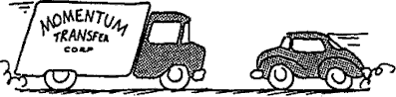

  - the Mack truck
  - the Volkswagen
  - both the same
  - ... it depends on other factors

